Project Summary Document

LibSpace - A Robust Backend for Library Operations
Team Details:
* Team Lead: Chandra Sekar G
* Team Members: Bharath H, Bhuvaneswaran G, Boopathi B L
1. Project Overview
LibSpace is a backend application designed to handle digital library operations. The system is built using Node.js, Express.js, and MongoDB. It provides secure user authentication using JSON Web Tokens (JWT) and allows authenticated users to perform CRUD (Create, Read, Update, Delete) operations on a centralized book database.
2. Technology Stack
* Runtime Environment: Node.js
* Backend Framework: Express.js
* Database: MongoDB
* Authentication: JSON Web Token (JWT)
* API Testing: Thunder Client
3. Project Architecture & Development Lifecycle
* Epic 1: Project Architecture
* Defined the Technical Architecture and ER Diagram.
* Mapped out core Features, Roles and Responsibilities, and the User Flow for authentication and book management.
* Epic 2: Project Setup and Configuration
* Created the Folder Structure.
* Initialized the Node.js project and installed necessary packages (Express, Mongoose, JWT, Bcrypt).
* Configured Environment Variables (.env).
* Started the Database, ran the Server, and accessed the application via local ports.

* Epic 3: Backend Development
* Developed the API routing logic for users and books.
* Integrated the database and built secure authentication middleware.
* Epic 4: Database Development
* Configured MongoDB and established the database connection.
* Created Mongoose Schemas/Models for User and Book collections.
* Epic 5: Project Execution and Testing
* Executed the project locally.
* Performed comprehensive API Testing using Thunder Client.
* Documented testing outputs and generated demo links.
4. Folder Structure
* Config/ - Contains database connection setup files.
* controller/ - Contains the core business logic and functions for each route.
* middlewares/ - Contains security files, like the JWT token verification.
* models/ - Contains the MongoDB database schemas (User and Book).
* routes/ - Contains the API endpoints.
* index.js - The main entry point and server setup file.
* .env - Stores secure environment variables.
5. API Testing & Execution Outputs
Step 1: Register New User
Successfully created a new user account with hashed passwords.
* Endpoint: POST /api/authuser/register
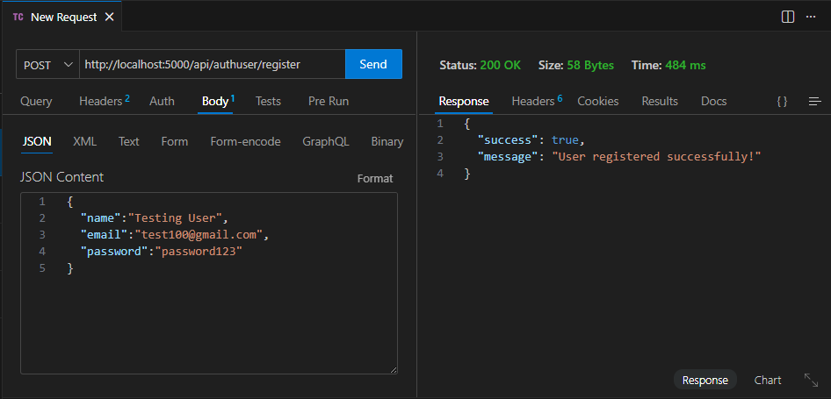

Step 2: User Login & Authentication
Successfully logged in the registered user and generated a secure JWT token for route protection.
* Endpoint: POST /api/authuser/login
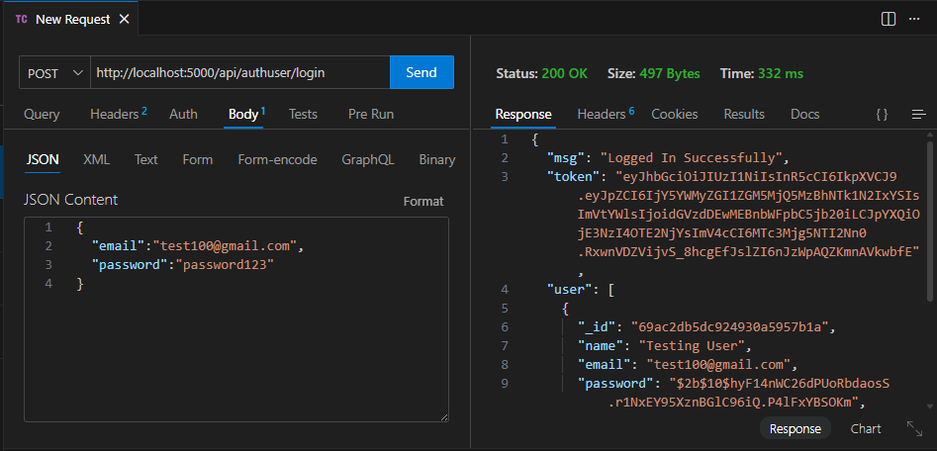

Step 3: Add a New Book (Create)
Successfully verified the JWT token and added a new book to the database.
* Endpoint: POST /api/book/addbook
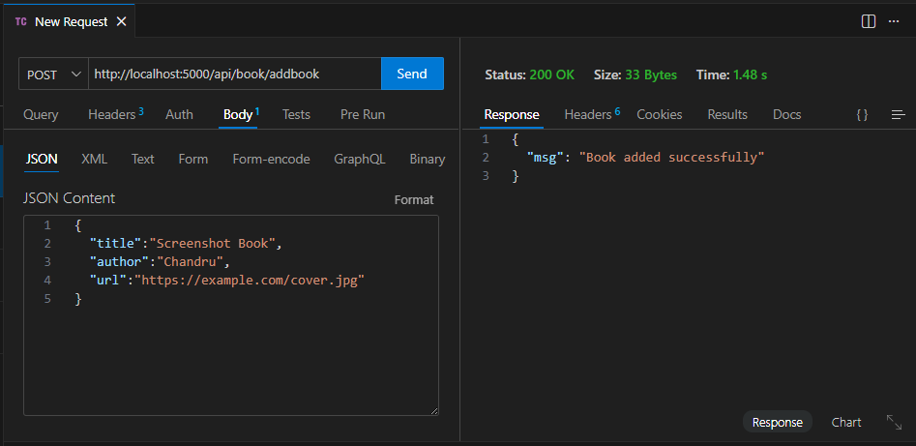

Step 4: View Available Books (Read All)
Successfully fetched the list of all books stored in the digital library.
* Endpoint: GET /api/book/getBooks
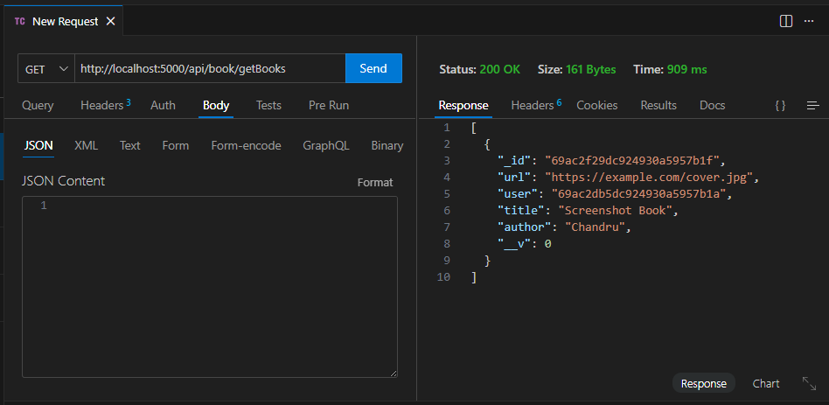

Step 5: Get Book by ID (Read Single)
Successfully fetched the specific details of a single book using its unique database ID.
* Endpoint: GET /api/book/<id>
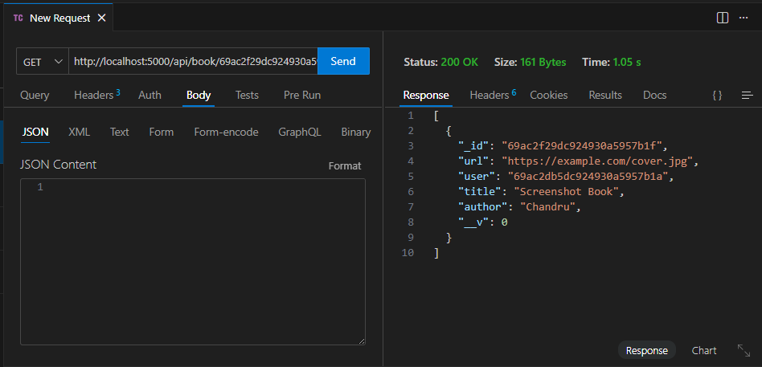

Step 6: Update Book Details (Update)
Successfully modified the title of an existing book in the database.
* Endpoint: PUT /api/book/<id>
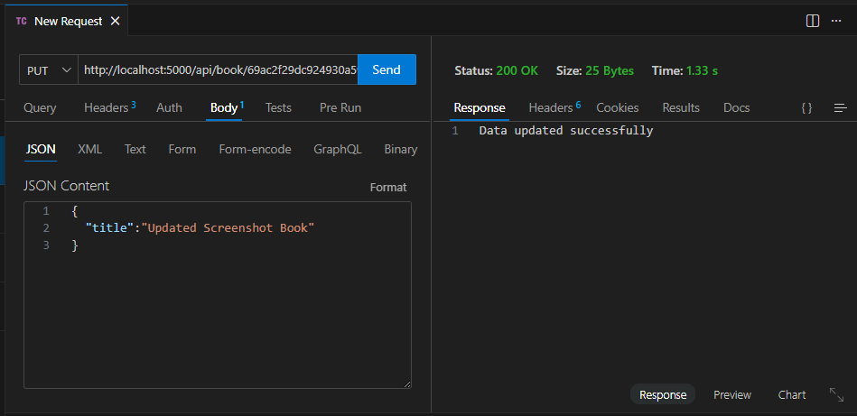

Step 7: Delete a Book (Delete)
Successfully removed the specific book from the library database.
* Endpoint: DELETE /api/book/deleteBook/<id>
